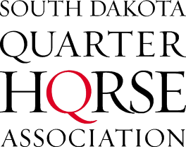
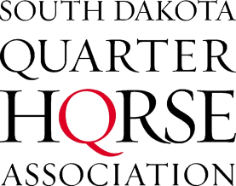
2019 SDQHA Membership Form

DUES: $35.00 for Individual - Family - Business – Corporation
Family Membership includes Husband/Wife and children 18 & under (open only). Children holding an amateur card or over the youth age of 18 must have their own membership as an individual.
Please note SDQHYA membership is a separate membership. Youth must have a separate membership to the SDQHYA to state qualify for the youth world or to earn youth points and awards in SDQHYA. Youth who exhibit a horse owned by someone else in their family must have the owner join the SDQHA.
Each person exhibiting the horse must have a membership and the owner must have a membership to the SDQHA prior to exhibiting for qualification for state points and awards.
NAME/BUSINESS:______________________________________________________
FAMILY_____INDIVIDUAL_____BUSINESS_____TRAINER_____(Mark One)
ADDRESS_______________________________________
CITY____________________________________STATE__________ZIP____________
EMAIL (important for SDQHA communications):__________________________________ PHONE:______________________
________ Check if you have enclosed an additional $10 to have your WEB or FACEBOOK URL linked on www.sdqha.com for the current membership year. ($10 for each link you would like advertised)
WEB/FACEBOOK URL:_________________________________________

WEB/FACEBOOK URL:_________________________________________

______ I do NOT want my membership information printed in official SDQHA publications
______ I do NOT want to receive informational mailings/emails from the SDQHA
Amateurs must designate at the time of membership if they want SDQHA points to go towards the amateur or the select amateur division. Please circle each family member’s division.
NAME:___________________________AMATEUR OPEN SELECT AMATEUR
NAME: __________________________ AMATEUR OPEN SELECT AMATEUR
NAME:___________________________AMATEUR OPEN SELECT AMATEUR
NAME:___________________________AMATEUR OPEN SELECT AMATEUR
Enclosed:
Send To:
Vicky Cuka- Secretary/Treasurer
12856 194th St.
Vale, SD 57788
Victoria.cuka@gmail.com

www.sdqha.com

https://www.facebook.com/South-Dakota-Quarter-Horse-Association-199118856954035/

_______ Membership Dues ($35)
_______ Web/Facebook link ($10 per link)
_______ Total

Paid with (if paid online please include invoice w/ form):
Card (sdqha.com/store) Check Cash

